Set a Vacation Rule
- Click on Vacation Rule link

- Click on Create Rule button.
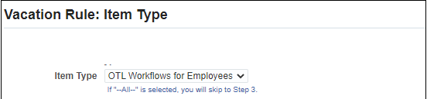
- Click on Item Type Drop Down Arrow
- To give access for All notifications, CHOOSE “All”
- To give access for HR notifications (example, LOA, Appraisals, etc.) CHOOSE “HR”
- To give access for Timecard notifications, CHOOSE “OTL Workflows for Employees”

- For this demonstration, we will choose the Timecard notifications item type.
Click on the NEXT Navigation Button to choose type of OTL Notifications.
Choose Notification “All”
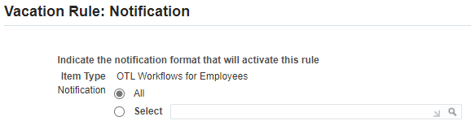

- Click on the NEXT Navigation Button
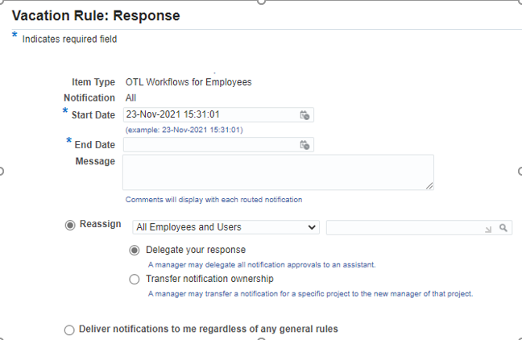
- Choose Start Date and End Date
Tip: Click on the Calendar Icon in the text box 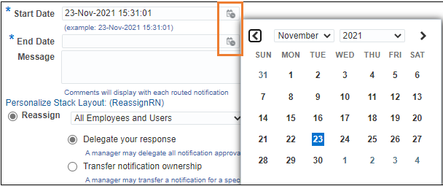

- Click on the Magnifying glass to Choose the Employee you are delegating your notifications to.
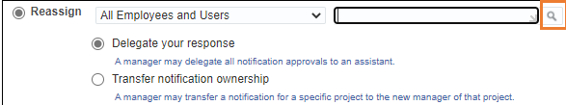
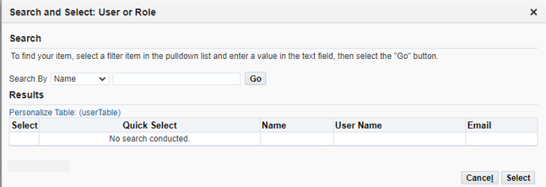
- To finish the steps, Click Apply

- The Rule Name, Item Type, and Notification Type will appear

In addition, the Update/Delete Icons and Current Status of Rule appear.
