How to identify Meaningful Work for Interns
An intern’s responsibilities may vary depending on whom you hire. Students searching for internships need to know the skills and duties required, significant projects he or she will complete and as much about the internship as possible prior to applying or interviewing. Given this information, applicants will have a clearer understanding of the internship and the field it will allow them to explore.
While such tasks as filing, answering a telephone or assembling mailings are routine with any job, these should not be the intern’s primary responsibilities unless they are in a program focused on developing office assistant skills. Remember that the student is participating in the internship to gain experience in his or her field. However, these secondary tasks need not be excluded – it is important to provide an intern with a genuine work experience.
The most essential step to a successful internship is deciding what kinds of work and projects the intern will do and managing the process throughout the internship. Interns want to be challenged. The top issue in unsuccessful internships is not having enough work for the intern to do – rarely is the reverse true. The best way to structure the internship work is to plan for three types of work:
- Project work – This can be a special analysis or project that will require the intern to use his/her skills related to his/her major area of study. This work should be what draws the applicants to this position to give them experience for his/her future career.

- Background work – This should be some general work that is not time-sensitive and may be less than exciting, but the work is important and requires some skill. The intern should be able to keep busy and feel productive with this work during times when the project work is “on hold” (i.e., waiting for approval or clarification).

- Unexpected work on issues that arise during the normal ebb and flow of business – This could also be called “helping put out the fires”. Providing interns with a taste of the true nature of your department and the wide variety of issues that employees must handle is a valuable experience. Interns appreciate the challenge and variety that comes from helping with these new tasks.
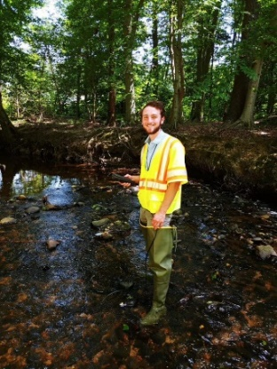
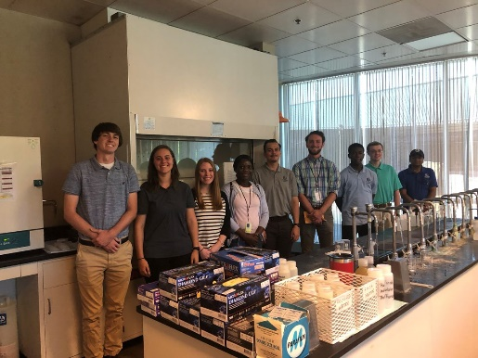
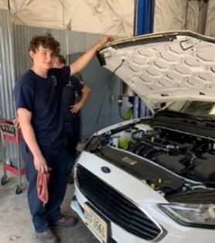
Some Potential Examples of Work for Interns
- Create support materials such as charts, graphics, spreadsheets, and other visuals  - Prepare presentations  - Attend staff meetings  - Assist in projects  - Collect, compile, and present statistics  - Create proposals  - Critique website for usability  - Plan and coordinate event or meeting  - Create a county manual  - Organize community hearings  - Perform inventories  - Analyze citizen fees  - Write reports for courts  - Attend meetings with community leaders: civic, government, business and political  - Develop a financial forecast  - Perform study or survey including analysis and recommendations  - Analyze and present survey results  - Write internal communications  - Benchmarking studies  - Collect and analyze data | - Develop comprehensive plan  - Website creation/development  - Analytical and administrative work  - Draft policy  - Create databases  - Create Best Practices  - Analyze department budgets  - GIS projects  - Research topics for training classes  - Attend Board of Supervisors meetings  - Manage stock, take inventory, receive, and ship materials, maintain database of materials  - Assist in mechanical repairs to pumps, compressors,  and tanks  - Assist in instrumentation and electrical repairs  - Assist in fabrication of parts and blueprint reading  - Prepare glassware and samples for analysis in Labs  - Perform a wide variety of laboratory tests  - Prepare reagents and standards used in analytical procedures  - Conduct sample preparation through digestion, filtration, and dilution
High School interns should work on duties related and relevant to their specific Career and Technical Education (CTE) Program, interest, and goals where possible.

